12,916

***MyPower is now the largest***

***youth development program in Lea County***.

***MyPower, Inc.* Background and Progress**

Since 2010, ***MyPower, Inc***. has worked with 13,102 5th – 8th grade girls in its ***MyPower*** Elementary Mentoring Circles, the ***MyPower*** Middle School Edition, and ***MyPower*** Leadership Camps to empower our youth to make wise choices, set goals, succeed academically, and avoid teen pregnancy.

Image result for down arrow graphic**Teen Birth Rates are DOWN in Lea County**

Image result for down arrow graphic**84% for the 15-17-year-olds and**

**65.5% for the 15-19-year-olds since 2009!**

Addressing the tough issues and alarming statistics for STD's and teen pregnancy in Lea County, ***MyPower*** has worked closely with the Hobbs Municipal Schools (HMS) to implement major changes in the sex education program for 7th – 10th graders. This change to Abstinence PLUS information, evidenced-based programs was exciting news for the Hobbs community. Science and health teachers teach factual information, and parents can choose to "opt-out" their children from the program. ***MyPower*** advocated for this change and commends the HMS Board for implementing the new policy.

***MyPower* Offers Three Quality Programs to All Girls at NO-COST**: **(Pilot Boys Program Launched 2024)**

* ***MyPower*'**s **Mentoring Circles** work with girls in their last year of elementary school (5th grade) in the following nine elementary schools: Southern Heights, Jefferson, Will Rogers, Booker T. Washington, Edison, Mills, Coronado, Mettie Jordan (Eunice), and Jal Elementary. These Circles are held after school from January-April, once a week, for 12 weeks. 50 women volunteer their time to make this program possible each year. 83% of students participate.
* ***MyPower's*** Pilot Mentoring Circles work with boys in their last year of elementary school (5th grade) at Mills Elementary. These Circles are held after school from January-April, once a week, for 12 weeks. 7 men will be volunteering their time to make this program possible. 85% of students are participating.
* ***MyPower's*** **Middle School Edition** has 1,000 girls participate in our six-session program at Heizer, Houston, Highland, and Caton Middle School (Eunice). These sessions are held during the advisory/home room period and offer an energetic and inspiring study of the Quantum Learning Keys of Excellence and real-life scenarios. These sessions are facilitated by ***MyPower*** staff and trained volunteers for 6th, 7th, and 8th graders.

* ***MyPower*** **Leadership Camps** have had 2,994 middle school girls participate in exciting life skills and academic strategy camps at the University of the Southwest campus, Training Center, Hobbs High School, and Freshman Commons since 2010. Many of the hired facilitators are teachers, who are provided with hands-on teaching strategies to later implement in their classroom.

**The Alarming Statistics for Lea County**

***MyPower*** was founded in 2009 specifically to address Lea County's alarming teen pregnancy and STD rates. New Mexico has consistently moved between 1st and 3rd place nationally. As of 2023, New Mexico ranks #10 in the United States for teen births. The U.S. leads the industrial world in teen births. While rates are down in Lea County since 2009, there is still a long way to go.

**Teen Birth Rates are DOWN by 84% in Lea County**

**for the 15-17-Year-Olds Since 2009!**

New Mexico Birth Certificate Database, Bureau of Vital Records and Health Statistics, New Mexico Department of Health, 2023

New Mexico Indicator-Based Information Systems (NM-IBIS), 2023/Cases per 1,000 Population

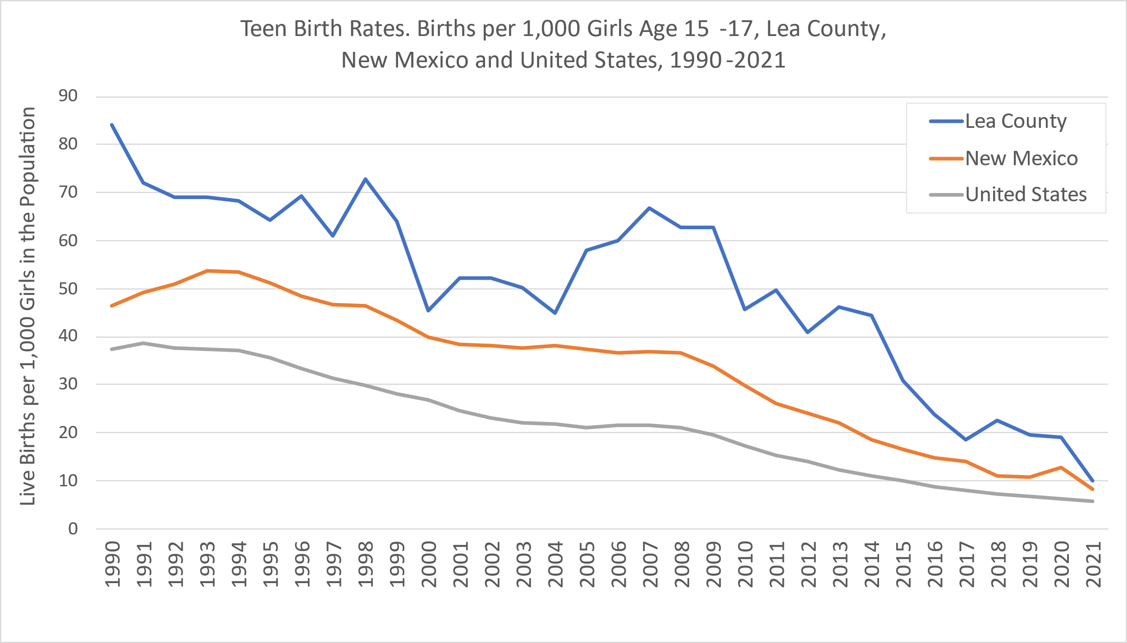

**Teen Birth Rates are DOWN by 65.5% in Lea County**

**for the 15-19-Year-Olds Since 2009!**

New Mexico Birth Certificate Database, Bureau of Vital Records and Health Statistics, New Mexico Department of Health, 2023

New Mexico Indicator-Based Information Systems (NM-IBIS), 2023/Cases per 1,000 Population

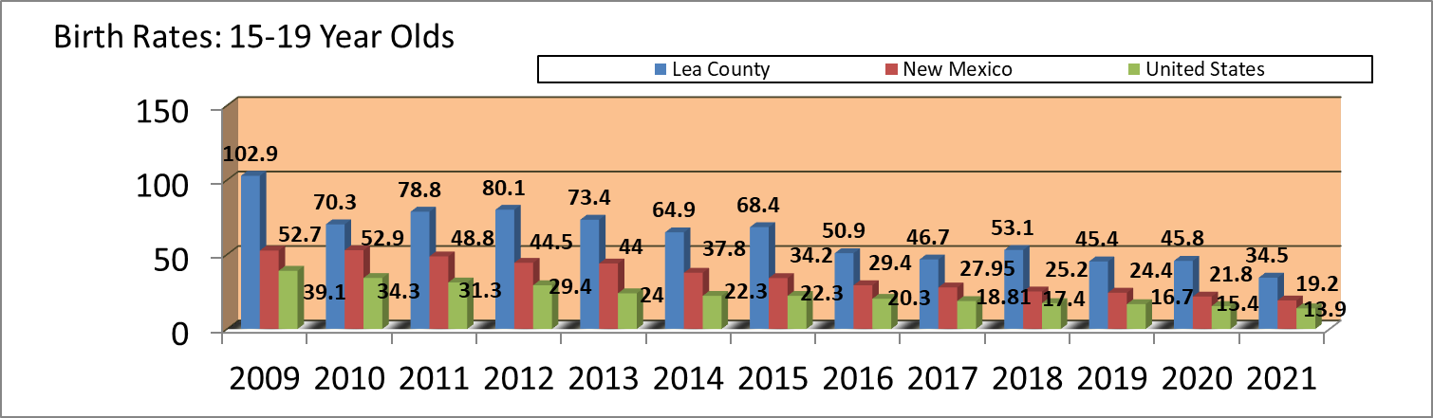

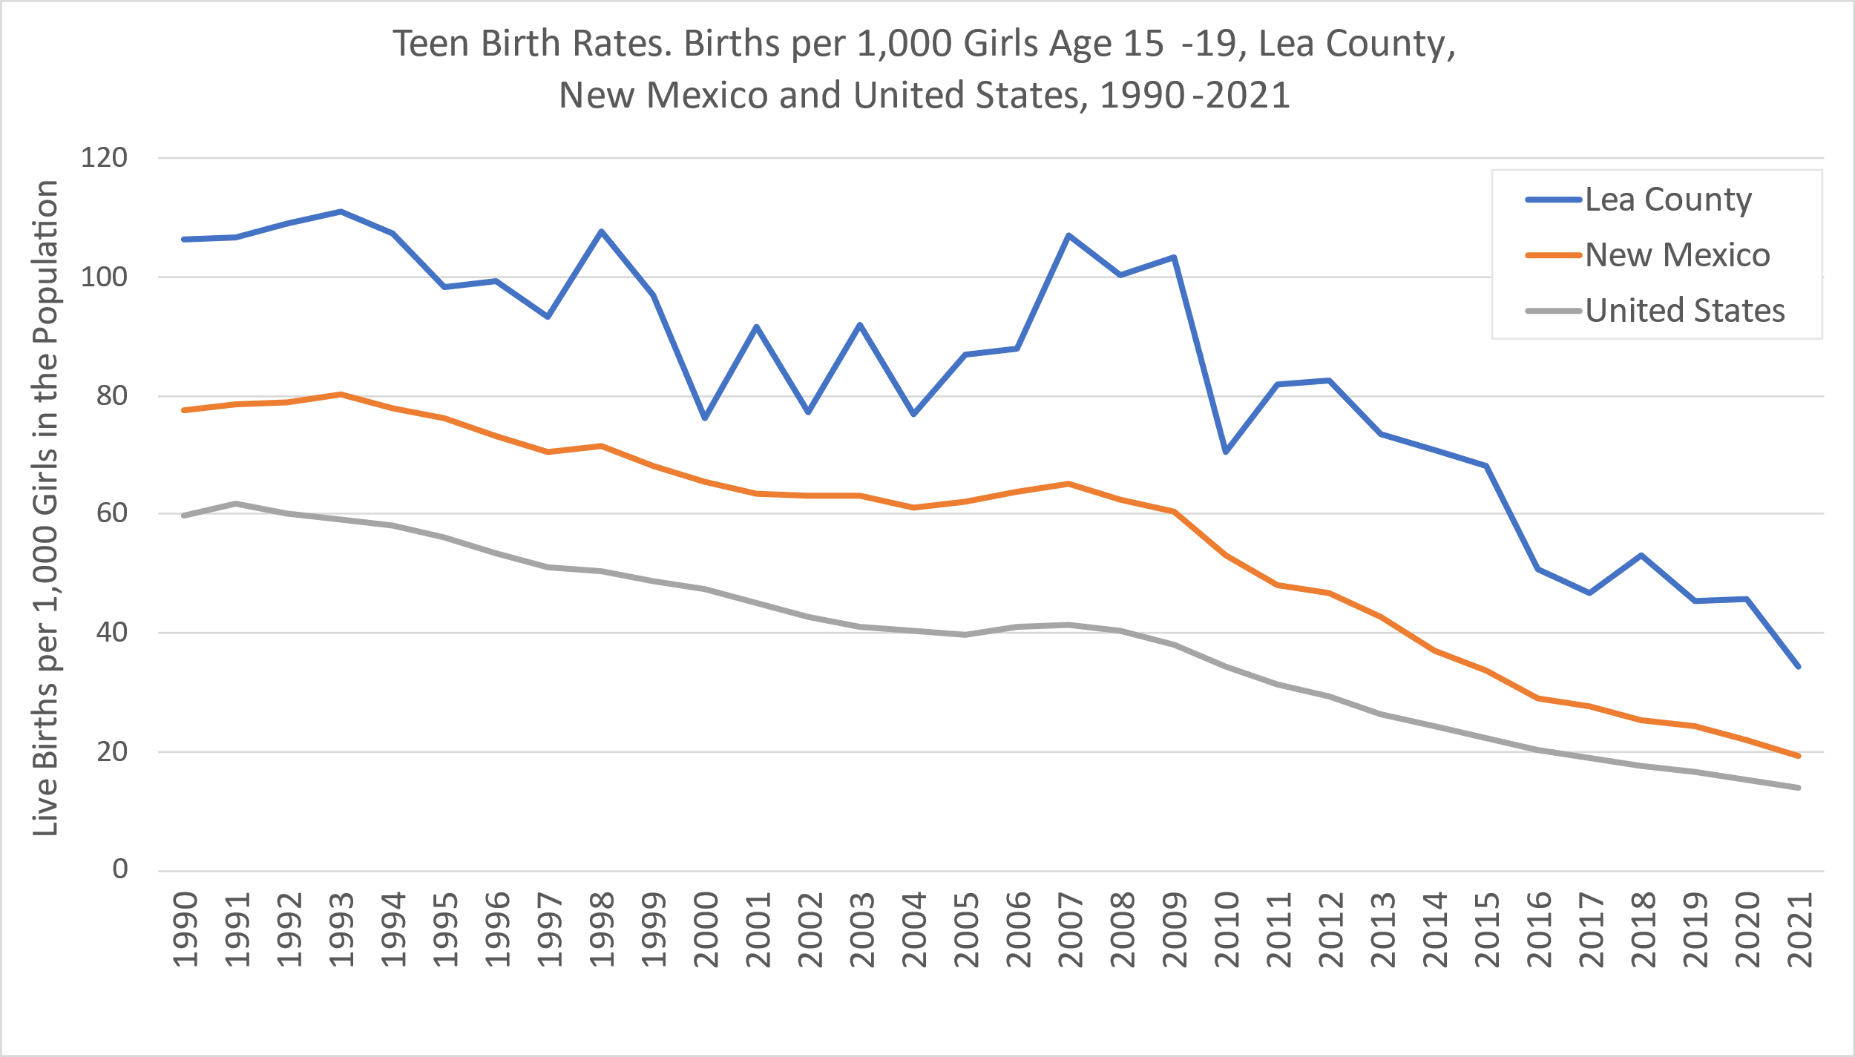

**Community Impact**

High teen pregnancy rates hurt communities, as less than 1/3 of teens who begin families before 18 ever complete high school; only 2% of teen mothers complete college before age 30; and the children of these parents are often not ready for school themselves and are more at risk for child abuse. In New Mexico, the gross impact of teenage parenting is more than $100 million annually (Source: Power to Decide). Single women who have a baby during the teen years are also at a high risk of poverty.

***MyPower, Inc****.* **Founded in 2009 to Empower Pre-Teen and Teen Girls**

***MyPower's*** program is **Abstinence PLUS Information** and is designed to help empower girls in grades 5-8 to successfully navigate the teen years by empowering them to make wise choices, set goals, succeed academically, and avoid risky sexual behavior and teen pregnancy. These youth development programs provide girls with straight talk about issues they will face as they enter the teen years. ***MyPower*** uses tools such as refusal skills, training and practice with real life situations to prepare these girls.

Specifically, our **Abstinence PLUS Information** curriculum works to empower girls to think about their goals, and it presents very straight talk concerning sexual issues, including basic facts of life, the importance of waiting, teen STD and teen birth statistics, how to prevent STDs, birth control options and the facts about common myths. ***MyPower's*** straight talk and Abstinence PLUS Information mentoring programs give girls the answers to their questions about the consequences of risky sexual behavior. ***MyPower*** utilizes area nurses and doctors who volunteer their time to present the anatomy and facts of life sessions, as well as the teen pregnancy and STD issue in the community.

***MyPower* Leadership Camps**

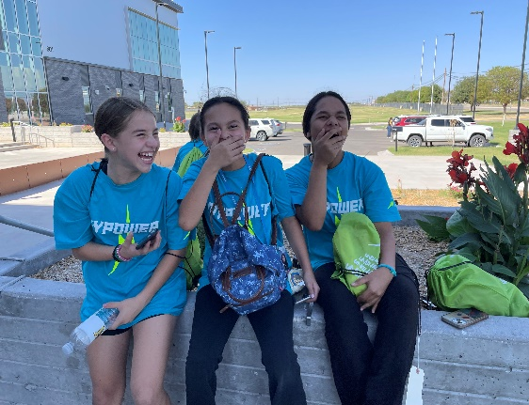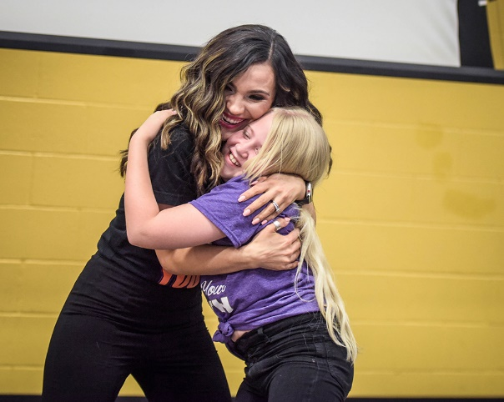

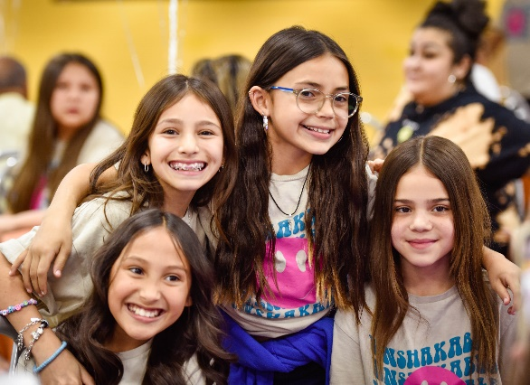

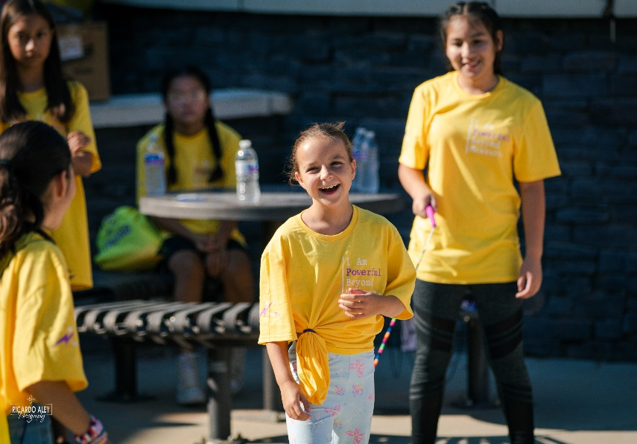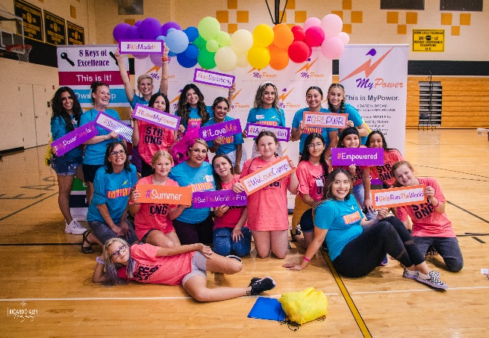

**Parent Meetings are an Essential Part of *MyPower***

Each year, ***MyPower*** meets with more than 1,200 parents and community members about the alarming STD and teen birth rates in Lea County. For parents, ***MyPower*** distributes straight forward materials from the Power to Decide, the National Campaign to Prevent Teen Pregnancy, that provide advice on talking to children about sexual issues.

***MyPower*** **Mentoring Circles**

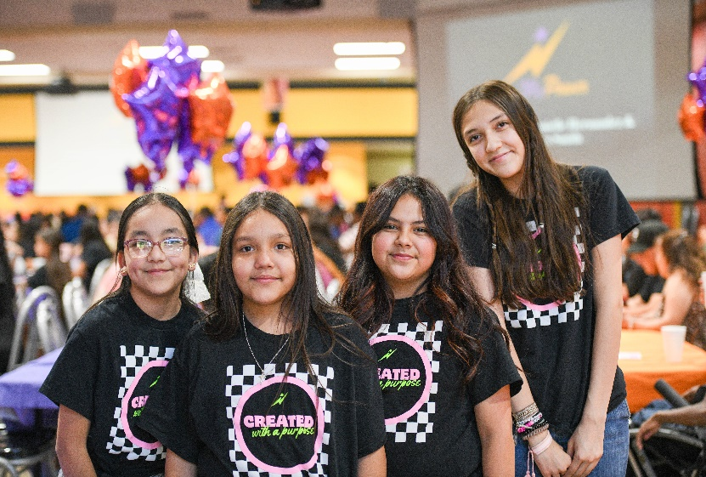

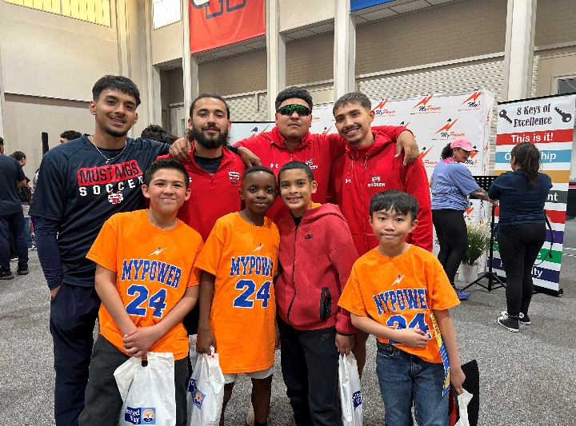

***MyPower's*** message is that it takes an entire community to address this crisis – parents, schools, churches, our political leaders, and committed volunteers. The City of Hobbs, the Lea County Commission, the J. F Maddox Foundation, Chevron North America, URENCO USA, the MyPower Board of Director members, the Stevan and Cynthia Pearce Foundation, Watson Truck & Supply, and many local businesses and individuals have stepped up to help fund our programs. (Businesses named have contributed more than $15,000. Please see "Passing on the Power.”).

***MyPower*** **Middle School Edition**

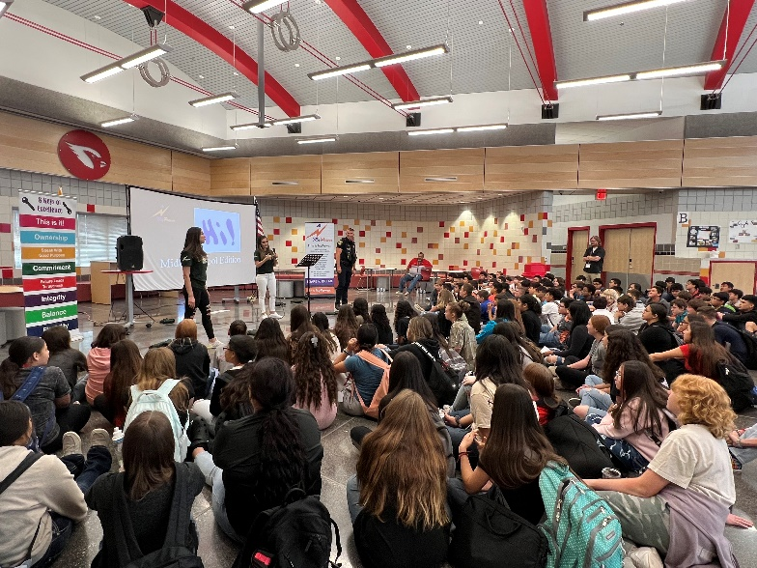

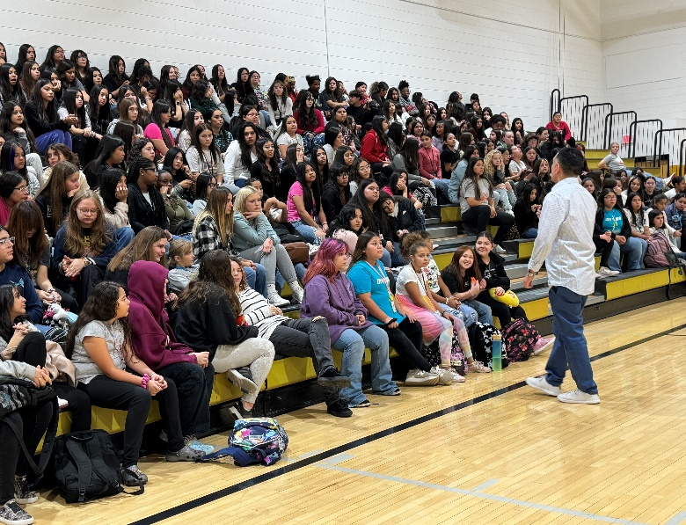

**Sexually Transmitted Diseases Among Teens at Epidemic Levels**

FACT: Long-term health issues from STDs can result from a lack of treatment. Girls are often non-symptomatic for many STDs, and these diseases can result in health issues like long-term pain, sterility, and even cancer.

**Cases per 100,000 Population**

**nmhealth.org, 2024**

**Center for Disease Control and Prevention, 2024**

Sexually active young people are at a higher risk of getting chlamydia. This is due to behaviors and biological factors common among young people. Most people who have chlamydia have no symptoms. If someone does have symptoms, they may not appear until several weeks after they have sex with an infected partner. Even when chlamydia causes no symptoms, it can damage one's reproductive system. Although chlamydia can be cured with the right treatment, it is important one take all of the medication their doctor prescribes to cure the infection. When taken properly it will stop the infection and could decrease chances of having complications later on.

SOURCE: www.nmhealth.org, 2024

**Cases per 100,000 population**

**Nmhealth.org, 2024**

**Center for Disease Control and Prevention, 2024**

Sexually active young people are at a higher risk of getting gonorrhea. According to the CDC New Mexico saw a 11.2% increase from 2020-2021 and a 18.3% decrease from 2021-2022. New Mexico is currently ranked 20th in the nation in 2022. Most women with gonorrhea do not have any symptoms. Even when a woman has symptoms, they are often mild and can be mistaken for a bladder or vaginal infection. Women with gonorrhea are at risk of developing serious complications from the infection, even if they don't have any symptoms. [Gonorrhea can be cured with the right treatment](https://www.cdc.gov/std/gonorrhea/treatment.htm). It is important that one take all of the medication their doctor prescribes to cure the infection. Medication for gonorrhea should not be shared with anyone. Although medication will stop the infection, it will not undo any permanent damage caused by the disease.

It is becoming harder to treat some gonorrhea, as [drug-resistant strains of gonorrhea](https://www.cdc.gov/std/gonorrhea/arg/default.htm) are increasing. If symptoms continue for more than a few days after receiving treatment, one should return to a health care provider to be checked again.

SOURCE: www.nmhealth.org, 2024

**Cases per 100,000 population**

**Nmhealth.org, 2024**

**Center for Disease Control and Prevention, 2024**

[Syphilis](https://www.cdc.gov/std/syphilis/default.htm) is a sexually transmitted disease caused by a bacteria that produces sores on the infected person. If left untreated, the bacteria can invade the nervous system, according to the CDC. People can experience illness and pass syphilis to their babies during pregnancy. Miscarriage, stillbirth, severe lifelong health problems, and even newborn death can result from syphilis infection during pregnancy. In 2022, there were 231 stillbirths and 51 infant deaths. New Mexico has second highest syphilis rate in US, according to the CDC.

**Parent Comments**

***MyPower Mentoring Circles***

**"My son said he enjoyed attending the University of the Southwest and wants to go there after graduating High School. Thank you for showing him his future."**

**"My son has really enjoyed MyPower. I can see changes in his attitude and outlook on life. MyPower has helped him uncover confidence and respect for himself and others. I am very pleased and impressed by the men and women that pour love and wisdom into our youth."**

**"He actually enjoyed going to school, and it made him realize he needed to take better care of himself."**

**"I would recommend this program to ALL girls. This program has opened the doors to conversations that my daughter should have had a long time ago. It made it easy to talk to about issues that she is facing and will face".**

**"I wish I would have had this opportunity in school. They learn so much about themselves and who they can become. They see what can be achieved when they set goals. Thank you for spending time with my daughter!"**

**"My child's confidence has gone thru the roof. She's more open and happy she was always excited about her MyPower day at school. I'm so glad she had the chance to do this program.**

**"I would recommend this program for other young girls. I loved it and my daughter did too. I am so glad there is a program for our young ladies. I wish there would have been something like this when I was growing up".**

**"MyPower has helped my daughter to be more confident in herself and her plans for the future. Her focus is college, a career and then a family!"**

**"This is the place that helps parents instill positive attitudes in our young women. It builds confidence in our girls. Wonderful program!"**

**"MyPower promotes a positive self-image and focuses on issues that are sometimes difficult for parents to start conversations about."**

“We want the youth in our community

to know that they have the power to choose

the life they want by the choices they make.”

-Danielle Hernandez, MBA /Executive Director

**Parent Comments**

***MyPower Leadership Camps***

**"I would highly recommend this program because it is a forum that builds high self- esteem and gives them "tools" to rise above peer-pressure and negative influences to obtain goals in which they have set."**

**"My daughter likes that she matters."**

**"She has learned to be herself and no longer is afraid of what others think about her. She knows she has a voice and can express herself more without being afraid."**

**"This truly is a miracle program."**

**"My daughter's attitude has improved 1,000%. She is more positive and more pleasant to be around."**

**"My daughter sees a wonderful future for herself! She doesn't see boyfriends, children and failure anymore. She sees college, career success and self-confidence."**

**"I would recommend MyPower, because it paves the way for child-parent communication. It also taught my daughter self-confidence and to accept herself for who she is."**

**"Knowledge is power".**

**"MyPower teaches self-love, kindness, setting boundaries, communication, honesty, and accountability."**

**"This program empowers our girls, gives them great information about themselves, and reminds them of the inner power they have."**

**"It has helped her learn to stick to something she starts and not give up. She learned just how valuable she is and that she is capable of so much".**

**"Girls this age have a hard time adjusting to their life and this experience gives them hope and opens their eyes to the future. It's okay to be yourself! Thank you, MyPower!"**

**"My daughter is more positive and her behavior has improved. She is more loving and more willing to try new things because of MyPower."**

**"MyPower helped my daughter blossom and realize she matters and that she can make a difference in our community. Thank you for empowering our youth and future leaders!"**

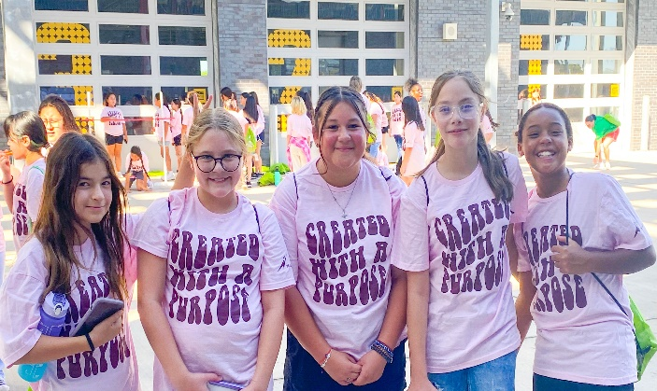

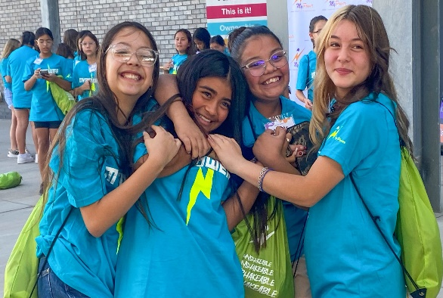

***MyPower's* Mission**

To empower Lea County's youth to reach their full individual potential by providing FUN, social, and learning activities geared toward developing personal confidence, academic excellence, and enhanced life skills.

***MyPower's* Goals**

***Training and Mentorship***: Target Lea County's youth at critical developmental stages for engaging academic and social skills activities, with a goal to provide open communications about the long-term benefits of staying in school, choosing friends wisely, and making healthy choices.

***Vision for the Future***: Expose participants to new ideas, skills, mentorship, and the limitless possibilities and opportunities available to all youth, regardless of race or socioeconomic background.

***Constructive Life Choices*:** Increase knowledge of how to make positive personal decisions and constructive life choices, especially with the temptations of drug abuse and teenage sex, regardless of peer pressure or other outside negative factors.

***La alegría de vivir***: Enhance their spirit to enjoy life and plan for the future using fun learning activities and exercises designed to boost personal confidence and self-concept.

***MyPower, Inc.* Board Members:**

Shannon Arguello, Court Administrator, Hobbs Municipal Court

Valerie Chacon, City Attorney, City of Hobbs

Megan Chavarria, Nurse Practitioner, Presbyterian Medical Services

Ty Elliott, Computer Specialist, New Mexico Jr. College

Mark Doporto, Fire Chief, Hobbs Fire Department

Tiffany Garcia, Family Nurse Practitioner, Eagles Student Health Center

Lisa Griffith, LCSW, Ohio University

Lisa Hardison, Ed.D., URENCO USA

Reanna Molinaro, Public Relations Sgt., Hobbs Police Department

Valerie Onsurez Gauna, Director of Marketing & Public Relations, NMJC

Evelyn Rising, Health Extension Rural Officer, University of New Mexico

Erik Jimenez, Assistant Foreman EPM DBBU, Devon Energy

Steven Williams, CPA, Dean Dorton

Sarah Yue, Nurse Practitioner, Lea Regional Hospital

Barry Young, Senior Safety & Emergency Preparedness Specialist, URENCO USA

**Board Officers & Executive Committee:**  **MyPower, Inc. Staff:**

Danielle Hernandez - Executive Director

Mike Hendon- Program Director

Jordyn Titus - Executive Assistant

Valerie Onsurez Gauna - President

Sarah Yue – 1st Vice President

Shannon Arguello – 2nd Vice President

Ty Elliott - Secretary

Steven Williams - Treasurer